SKILL-14
- To Parse Append Operator, Open Files in Append Mode, Redirect Streams, Preserve Existing Data, Validate Appends, Test Scenarios.
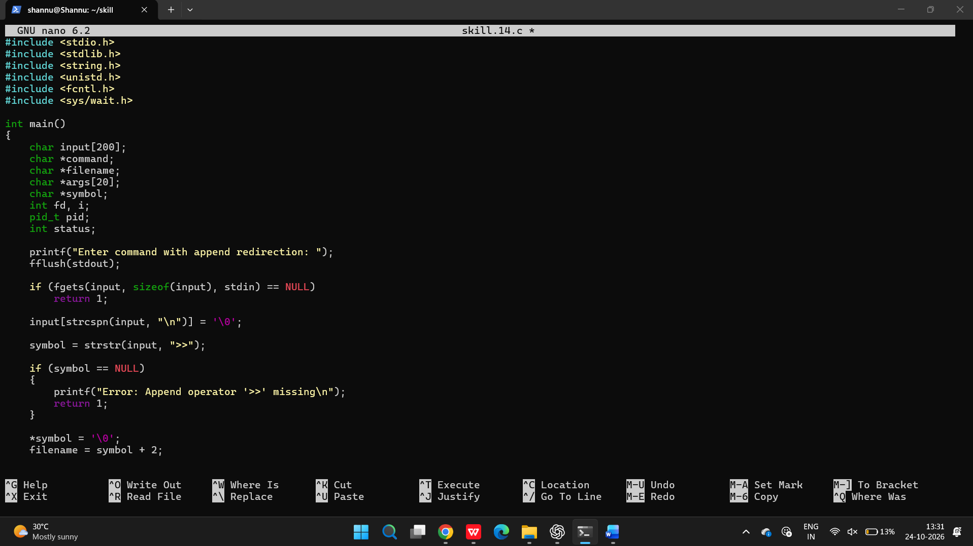
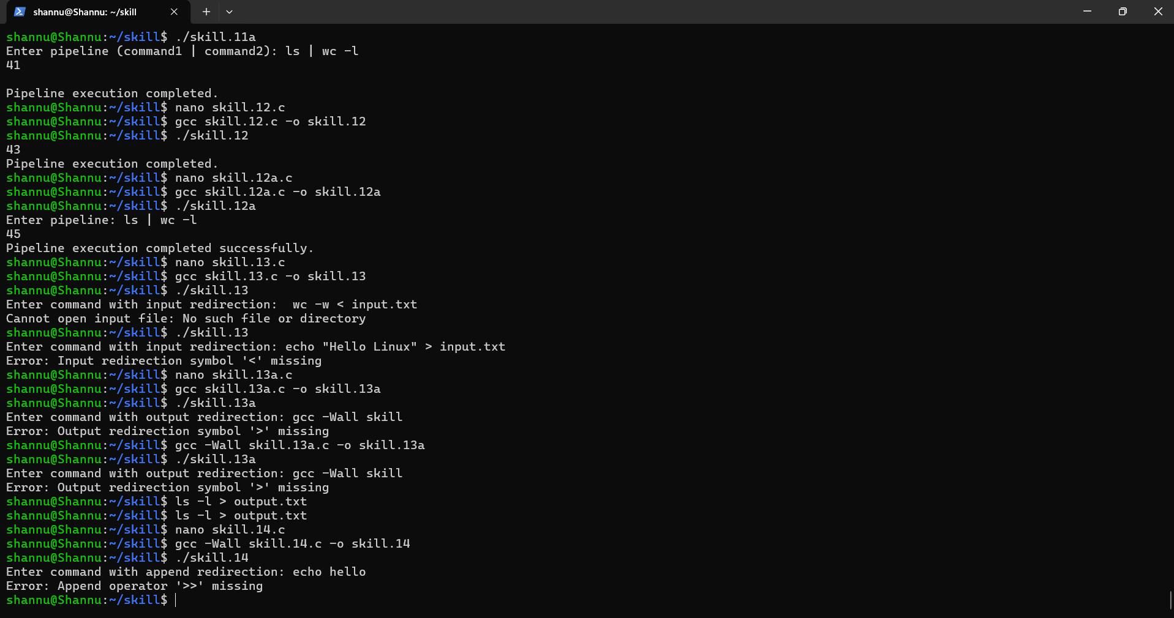

To Parse stderr Redirection, Redirect Error Streams, Capture Error Output, Verify File Contents, Handle Failures, Test Error Cases.
